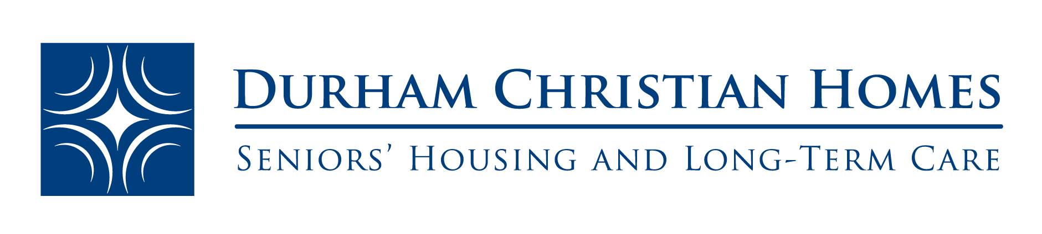

Job Title: Maintenance Supervisor
Position Type: Full Time
__________________________________________________________________________________
Durham Christian Homes is currently recruiting for the full time position of Maintenance Supervisor

The Maintenance Supervisor is responsible for the coordination of building upgrades and refurbishments specifically within our senior living buildings, Tekoa Manor and Providence Place. This position is also responsible for ensuring the safe and efficient operation of the building systems, including regular maintenance, coordinating service calls and being the point of contact for maintenance and building contractors.
The duties and responsibilities of the Maintenance Supervisor include, but are not limited to:
Duties and Responsibilities
- Responsible for the supervision of the maintenance and custodial staff,
- Coordinate the regular maintenance and service of equipment and internal systems (e.g. heating, alarms, plumbing, fire panels, etc.);
- Liaise with vendors and suppliers on behalf of Senior Management;
- Oversee the workflow of subcontractors involved in assigned projects and renovations;
- Coordinate and complete annual unit inspections;
- Plan and ensure efficient implementation of building upgrades and unit turnover refurbishments;
- Ensure Purchasing Policy is adhered to with when obtaining quotes and the required approvals;
- Coordinate after hours security to ensure adequate coverage;
- Lead for the Joint Health and Safety Committee and ensure compliance with health and safety regulations;
- Order building supplies in a timely and cost-effective manner;
- Provide facility tours as requested;
- Provide back up relief for reception area as needed;
- Adhere to Durham Christian Home’s policies and procedures;
- Work respectfully and maintain confidentially with residents, co-workers, and the organization;
- Other duties as assigned
Qualifications
- Facilities Management Diploma/Certificate (completed and/or in progress)
- Two years of experience in building coordination or project management preferred
- General knowledge of building and equipment maintenance
- Ability to coordinate and respond to building and equipment emergencies;
- Good interpersonal and problem-solving skills are essential;
- Flexibility on some work hours and on call availability
- Excellent written, verbal communication and organizational skills

Interested applicants are encouraged to email your resume and cover letter to careers@dchomes.ca.
No phone calls please, only those selected for an interview will be contacted.

